CS3211 Project 2

Group 10

Chua Zheng Long | U087058R | u0807058@nus.edu.sg
Ma Zhencai | U087139J | u0807139@nus.edu.sg
Ng Jie Zhi | U087048W | u0807048@nus.edu.sg

Documentation

The find generators algorithm consists of three main components – finding all prime numbers, finding all prime factors, and determining all generators.

For crypto_sieve.c implementation:
The first component is in-charge of finding all prime numbers that are less than the prime number p. To accomplish this, the Sieve of Eratosthenes algorithm is implemented. Each process is given an equal portion of numbers from 2 to p-1. Each process will run the numbers allocated to them through the Sieve of Eratosthenes algorithm to determine if they are prime. Prime numbers will be stored in the local_prime array, before being merged into the global_prime array through MPI_Gatherv. This component is implemented with optimization in mind. Having only prime numbers to compute will speed up the next component by at least 50% (the worst case scenario is when only non-prime even numbers are removed).

For crypto_trial.c implementation:
The first component is in-charge of finding all prime numbers that are less than the prime number p. To accomplish this, the Trial Division algorithm is implemented. Each process is given an equal portion of numbers from 5 to p-1; prime check for 2 & 3 are done initially. Each process will run the numbers allocated to them through the Trial Division algorithm to determine if they are prime. Prime numbers will be returned to the master process, which will consolidate all the results. This component is implemented with optimization in mind. Having only prime numbers to compute will speed up the next component by at least 50% (the worst case scenario is when only non-prime even numbers are removed).

The second component is in-charge of finding all prime factors lesser than prime number p. With the array of prime numbers from the first component, each slave process will be allocated an equal share among the slave process, while the master process will receive a smaller share. For example, there are 20 prime numbers to be distributed among 4 processes (1 master process & 3 slave processes). Thus each slave process will be given 6 (20/4+1) prime numbers to compute, while the master process will only receive the remaining 2 prime numbers (20-6*3). This is to ensure that the master process will be done earlier than the slave processes to be able to wait for the incoming messages.
An alternative distribution method considered is to have the work distributed among the slave processes only. Following the above example of 20 prime numbers to be distributed among 4 processes (1 master process & 3 slave processes), each slave process will be allocated 6 to 7 (20/3) primes numbers, while the master process will receive none. Although the master process will be ready to receive any incoming messages from the start, the slave processes are required to compute an additional prime number, resulting in a overall longer computation time. Rather than having the master process idle, it is more efficient to distribute a smaller workload to it.
The find factors algorithm used is from the python file. However, our implementation is faster as only prime numbers are being computed. All prime numbers that have been determined to be factors of prime number p will be sent to the master process.

The third component is in-charge of determining if the prime factors from the second component are generators. A similar task distribution method as the second component is employed. The find generator algorithm used is from the python file. All prime factors of p that have been determined to be generators as well will be sent to the master process.

Evaluation

crypto_sieve.c
Total time taken
Prime Number p | No. of Digits | No. of Processes
Prime Number p | No. of Digits | 2 | 4 | 8 | 16 | 32
101 | 3 | 0 | 0 | 0 | - | -
1009 | 4 | 0 | 0 | 0 | 0 | -
10007 | 5 | 0.01 | 0.01 | 0.01 | 0.01 | 0.02
100019 | 6 | 0.08 | 0.11 | 0.11 | 0.07 | 0.08
1000003 | 7 | 0.86 | 0.91 | 1.02 | 0.85 | 0.86
10000169 | 8 | 7.68 | 7.7 | 8.23 | 7.78 | 7.85
100000007 | 9 | 135.20 | 131.32 | 137.40 | 125.68 | 127.48
1000000007 | 10 | - | - | - | - | 1005.97

Max time taken for each process
Prime Number p | No. of Digits | No. of Processes
Prime Number p | No. of Digits | 2 | 4 | 8 | 16 | 32
101 | 3 | 0 | 0 | 0 | - | -
1009 | 4 | 0 | 0 | 0 | 0 | -
10007 | 5 | 0.01 | 0.01 | 0.01 | 0.01 | 0.01
100019 | 6 | 0.04 | 0.03 | 0.02 | 0.01 | 0.01
1000003 | 7 | 0.43 | 0.24 | 0.13 | 0.06 | 0.02
10000169 | 8 | 3.84 | 1.94 | 1.33 | 0.51 | 0.32
100000007 | 9 | 67.6 | 34.07 | 26.15 | 7.91 | 4.51
1000000007 | 10 | - | - | - | - | 34.88

crypto_trial.c
Total time taken
Prime Number p | No. of Digits | No. of Processes
Prime Number p | No. of Digits | 2 | 4 | 8 | 16 | 32
101 | 3 | - | 0 | 0 | 0 | 0
1009 | 4 | - | 0 | 0 | 0 | 0
10007 | 5 | - | 0.02 | 0.01 | 0.02 | 0.01
100019 | 6 | - | 0.1 | 0.08 | 0.08 | 0.08
1000003 | 7 | - | 0.79 | 0.8 | 0.83 | 0.73
10000169 | 8 | - | 6.23 | 6.26 | 6.32 | 6.22
100000007 | 9 | - | 98.42 | 109.2 | 100.53 | 100.21

Max time taken for each process
Prime Number p | No. of Digits | No. of Processes
Prime Number p | No. of Digits | 2 | 4 | 8 | 16 | 32
101 | 3 | - | 0 | 0 | 0 | 0
1009 | 4 | - | 0 | 0 | 0 | 0
10007 | 5 | - | 0.01 | 0.01 | 0.01 | 0.01
100019 | 6 | - | 0.03 | 0.01 | 0.01 | 0.01
1000003 | 7 | - | 0.2 | 0.11 | 0.07 | 0.03
10000169 | 8 | - | 1.57 | 0.79 | 0.43 | 0.2
100000007 | 9 | - | 25.01 | 14.16 | 6.58 | 3.14
Comparing the total time taken for different number of processes

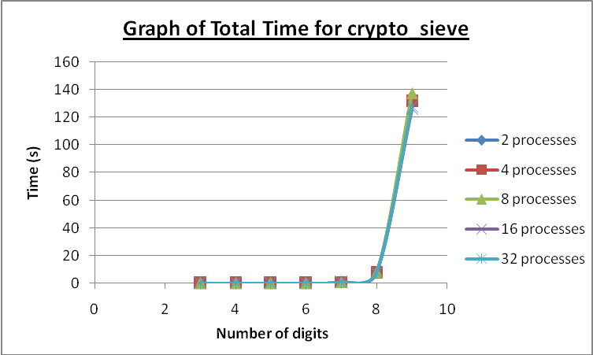

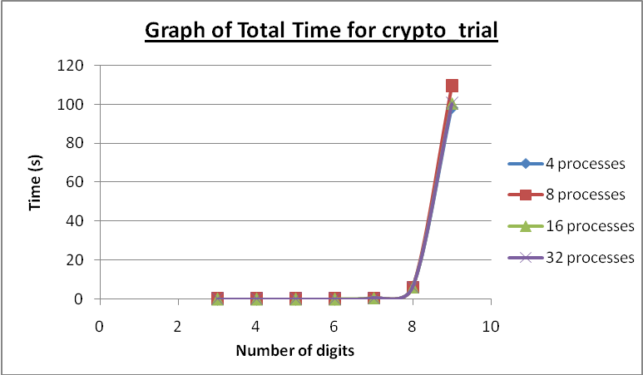

Based on the graphs above, the total time taken for both crypto_trial and crypto_sieve methods increases as the prime number have more digits. The total time for different number of processes are about the same; a reflection of the amount of time that a sequential implementation would take to complete.

The exponential increase in total time taken from the 8 digits onwards reveals that it is not feasible in practical to compute prime generators for large numbers sequentially, hence enforcing the importance of having parallel execution to redistribute the workload so as to reduce the amount of time required for such computation. Parallelism is extremely useful in cryptography where a number is required to be of significantly large size so as to be “unbreakable” in practice, but yet, to be able to encrypt and decrypt relatively fast.
Comparing the maximum time for different number of digits

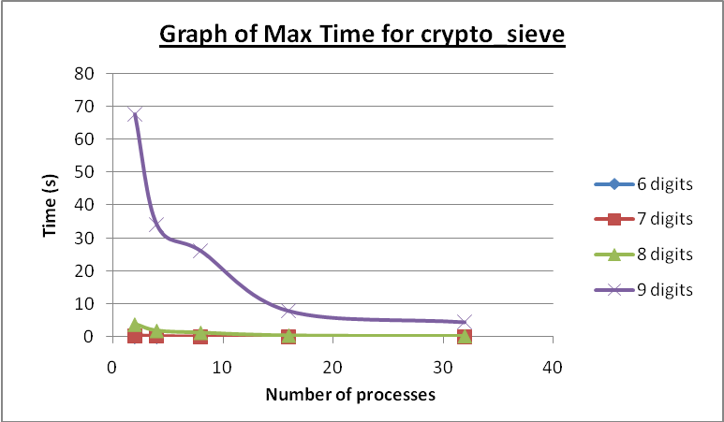

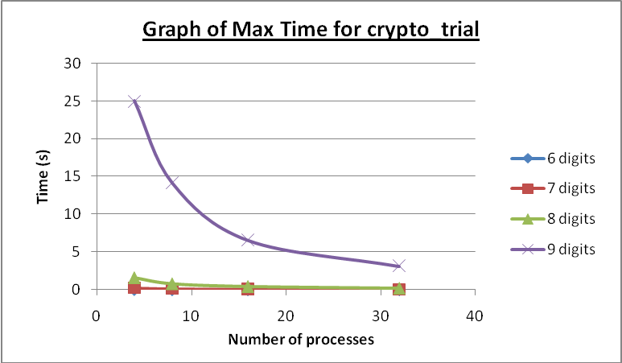
Based on the graphs above, it is generally observed that the maximum time taken for each process decreases as the number of processes increase. We can conclude that parallelism is implemented effectively and efficiently in our program as the maximum time taken is directly proportional to the number of processes allocated. This is an indication of the workload being distributed evenly among the processes.

The 9 digits graph for both crypto_sieve and crypto_trial reveals that crypto_sieve performs better with more processes allocated, whereas crypto_trial performs better relatively with lesser processes. We can conclude that the number of processes allocated should be a consideration when choosing the type of algorithm to implement in order to achieve maximum optimization. More processes does not necessary indicts better time reduction as the parallel implementation might not have the capability to fully utilized all the processes allocated.
Comparison of the Sieve of Eratosthenes implementation and the Trial Division implementation

The Sieve of Eratosthenes implementation has a flaw inherited from its algorithm. As the parallel implementation requires each process to be allocated at least one number to compute, the program will fail when the amount of numbers to be computed is less than the amount of processes allocated.

A solution to the above flaw will be to implement a check for the amount of numbers to be computed against the amount of processes allocated. If there are more than required processes, the excessive processes can be put to sleep, while the rest of the processes get a number to compute each. However, by having excessive processes in sleep mode, the full potential of parallelism is wasted. A sequential implementation might be more suitable for computing the generators of a relatively small prime number.

Despite the above shortcoming, the Sieve of Eratosthenes implementation truly shines when the prime number to be computed is of significantly large size. As seen from the table above, crypto_sieve is able to compute a 10 digit prime number with 32 processes allocated. crypto_trial on the other hand was unable to compute the 10 digit prime number even with 32 processes allocated.

The Trial Division implementation has its own flaws as well. In order to achieve parallelism, it is crucial to distribute the workload to each slave processes evenly. However, in the case of when only two processes are allocated, that is to say only a master process and a slave process, the amount of work distributed to the slave process would be so heavy that a sequential implementation would be more adequate. Hence the program fails when there are only two processes allocated.

However, as seen from the table of results and the graph, the Trial Division implementation is extremely efficient in computing relatively smaller prime numbers. The maximum time taken for the 3 digit prime till the 8 digit prime are all faster than the Sieve of Eratosthenes implementation.

In conclusion, our team believe that to achieve optimal efficiency with parallelism, different implementations are required for different problems. For a small-sized prime number, that is a 2 digit and below prime, a sequential implementation would be sufficient. For a medium-sized prime number, that is a 3 digit prime to the 8 digit prime, the trial-division implementation is the optimal. For 9 digits and above primes, the Sieve of Eratosthenes implementation is required.

Additionally, the workload distribution for parallel implementation on 2 processes is so unbalanced that a sequential implementation might actually be more efficient. For parallel implementation to be significant, at least an allocation of 4 processes is required.
Parallel Algorithm

crypto_sieve.c

#include <mpi.h>
#include <stdio.h>
#include <stdlib.h>
#include <unistd.h>
#include <string.h>
#include <math.h>
#include <sys/times.h>

#define MIN(a,b) ((a)<(b)?(a):(b))
#define BLOCK_LOW(id,p,n) ((id)*(n)/(p))
#define BLOCK_HIGH(id,p,n) (BLOCK_LOW(((id)+1),p,n)-1)
#define BLOCK_SIZE(id,p,n) ((BLOCK_LOW(((id)+1),p,n))-(BLOCK_LOW(id,p,n)))
#define BLOCK_OWNER(index,p,n) (((p)*(index)+1)-1)/(n))

long long p;

// declaration for sieve
int global_count; // global count of prime numbers
long long *global_prime; // array of all primes
int *process_prime_count; // array of counts of element in each process
int *process_prime_displ; // array of displacement to allocate

long long min,max;

long long findPrimeNumbers(long long p,int npes, int myrank);

int main(int argc, char *argv[])
{
int npes, myrank;
p = atoi(argv[1]);
min = atoi(argv[2]);
max = atoi(argv[3]);
long long local;
long long target = p-1;

struct tms b4,aft;
int cps;
float tim,total,max;
clock_t tm;

MPI_Status stat;
MPI_Init(&argc, &argv);
MPI_Comm_size(MPI_COMM_WORLD, &npes);
MPI_Comm_rank(MPI_COMM_WORLD, &myrank);
times(&b4);

// finding factors for p-1
// let's let all the cores generate the factors.. and send back to
// the master node...

// finding all the prime numbers
long long numPrime = findPrimeNumbers(target,npes,myrank);
// round up integer division
long long offset = (target+npes-1)/npes;
long long *factors = (long long*)malloc(sizeof(long long)*target);
if (factors==NULL) exit(1);
long long *buffer = (long long*)malloc(sizeof(long long)*target);
if (buffer==NULL) exit(1);

int numFactors=0;

if (myrank==0)
{
long long start,end;

unsigned int x;

long long prime_domain = (numPrime+npes-1) / npes;
long long *current_prime = global_prime;

for (x=1;x<npes;x++)
{
MPI_Send((void *)current_prime, prime_domain, MPI_LONG_LONG_INT, x, 0, MPI_COMM_WORLD);
current_prime += prime_domain;
}
start = (npes-1)*prime_domain;

// calculate my fair share of work
for (x=start;x<numPrime;x++)
{
if (target%global_prime[x]==0)
{
factors[numFactors] = global_prime[x];
numFactors++;
}
}
// i'm done... waiting for slaves and consolidating values
for (x=1;x<npes;x++)
{
MPI_Recv((void*)buffer,target,MPI_LONG_LONG_INT,x,MPI_ANY_TAG,MPI_COMM_WORLD,&stat);
int factorCount;
MPI_Get_count(&stat,MPI_LONG_LONG_INT,&factorCount);

int y;
for (y=0;y<factorCount;y++)
{
factors[numFactors] = buffer[y];
numFactors++;
}
}

// recieved all the factors... now we can redistribute the factors and let our slaves do some number crunching...
for (x=1;x<npes;x++)
{
// send factors for each machine

// notify each node about the size of the factor
// to enable them to prep memory for it
MPI_Send((void*)factors,numFactors,MPI_LONG_LONG_INT,x,0,MPI_COMM_WORLD);
}

// crunch some number on our side...
offset = (p+npes-1)/npes;
unsigned int resultTotal = 0;
start = offset*(npes-1);
if (start==0) start=2;

resultTotal += findGen(start,p,numFactors,factors);

// consolidate results
unsigned int recvResult;

for (x=1;x<npes;x++)
{
MPI_Recv((void*)&recvResult,1,MPI_INT,x,MPI_ANY_TAG,MPI_COMM_WORLD,&stat);
resultTotal += recvResult;
}

//we're done.. print results..

printf("Generator Size:%d\n",resultTotal);
}
else
{
int x;
int numFactors = 0;

// recieve prime list from master and test for factors
MPI_Recv((void*)buffer,target,MPI_LONG_LONG_INT,0,MPI_ANY_TAG,MPI_COMM_WORLD,&stat);
int numPrime;
MPI_Get_count(&stat,MPI_LONG_LONG_INT,&numPrime);

for (x=0;x<numPrime;x++)
{
if (target%buffer[x]==0)
{
// buffer[x] is a factor
factors[numFactors] = buffer[x];
numFactors++;
}
}
// done calculating, lets send back to the master
MPI_Send((void*)factors,numFactors,MPI_LONG_LONG_INT,0,0,MPI_COMM_WORLD);

// get the size of factors...
// let's wait for the new set of factors to crunch numbers...
MPI_Recv((void*)factors,target,MPI_LONG_LONG_INT,0,MPI_ANY_TAG,MPI_COMM_WORLD,&stat);
int factorSize;
MPI_Get_count(&stat,MPI_LONG_LONG_INT,&factorSize);
long long start,end,offset;
offset = (p+npes-1)/npes;
start = offset * (myrank-1);
end = start + offset;
if (start==0) start=2;

int generatorSize = findGen(start,end,factorSize,factors);

// we're done for our part... send back result to server
MPI_Send((void*)&generatorSize,1,MPI_INT,0,0,MPI_COMM_WORLD);

}

times(&aft);
cps = sysconf(_SC_CLK_TCK);
tm = aft.tms_utime - b4.tms_utime;
tim = ((float)tm)/cps;
printf( "User time from process %d is %6.3f seconds\n",myrank,tim );

MPI_Reduce((void *)&tim,(void *)&total,1,MPI_FLOAT,MPI_SUM,0,MPI_COMM_WORLD);
MPI_Reduce((void *)&tim,(void *)&max,1,MPI_FLOAT,MPI_MAX,0,MPI_COMM_WORLD);
if (myrank==0)
{
printf("Total time is %6.3f seconds\n",total);
printf("Maximum time is %6.3f seconds\n",max);
}

MPI_Finalize();
return 0;
}

int modexp (long long t,long long u,long long n)
{
long long lt, lu, ln;
lt = t;
lu = u;
ln = n;
// computes s = (t ^ u) mod n
long long ls = 1;
while (lu)
{
if (lu & 1)
{
ls = (ls * lt) % ln;
}
lu >>= 1;
lt = (lt * lt) % ln;
}
return ls;
}

int findGen(long long start, long long end,int factorSize, long long *myFactor)
{
int x;
int generatorSize=0;
for (x=start;x<end;x++)
{
int gen = 1;
int k;
for (k=0; k<factorSize; k++)
{
if (modexp(x, (p-1)/myFactor[k], p)==1)
{
gen=0;
break;
}
}
if (gen)
{
if (x>=min && x<=max)
printf("A generator for %d is %d.\n",p,x);
generatorSize++;
}
}
return generatorSize;
}

long long findPrimeNumbers(long long p,int npes, int myrank)
{
// find Prime Numbers using Sieve of Eratosthenes

// declaration
int local_count; // local prime count
long long first_sieve; // index of the first sieve
long long low_value; // lowest value assigned to this process
long long high_value; // highest value assigned to this process
long long index; // index of current sieve
long long *marked; // array of elements to be marked
long long marked_size; // size of elements in marked array
long long proc0_size; // number of elements assigned to process zero
long long current_sieve; // current sieve
long long *local_prime; // array of primes found by local process

low_value = 2 + BLOCK_LOW(myrank,npes,p-1);
high_value = 2 + BLOCK_HIGH(myrank,npes,p-1);
marked_size = BLOCK_SIZE(myrank,npes,p-1);
proc0_size = (p-1)/npes;

if ((2 + proc0_size) < (long long) sqrt((double)p))
{
if (!myrank)
{
printf ("Too many processes\n");
MPI_Finalize();
exit(1);
}
}

if (!myrank)
{
global_prime = (long long *) malloc (p * sizeof(long long));
if (global_prime == NULL)
{
printf ("Cannot allocate enough memory\n");
MPI_Finalize();
exit (1);
}
}

local_prime = (long long *) malloc (marked_size * sizeof(long long));
if (local_prime == NULL)
{
printf ("Cannot allocate enough memory\n");
MPI_Finalize();
exit (1);
}

marked = (long long *) malloc (marked_size * sizeof(long long));
if (marked == NULL)
{
printf ("Cannot allocate enough memory\n");
MPI_Finalize();
exit (1);
}

process_prime_count = (int *)malloc(npes*sizeof(int));
if (process_prime_count == NULL)
{
printf ("Cannot allocate enough memory\n");
MPI_Finalize();
exit (1);
}

process_prime_displ = (int *)malloc(npes*sizeof(int));
if (process_prime_displ == NULL)
{
printf ("Cannot allocate enough memory\n");
MPI_Finalize();
exit (1);
}

// initialise the marked array
unsigned long long i;
for (i=0; i<marked_size; i++)
{
marked[i] = 0;
}

if (!myrank)
{
index = 0;
}

current_sieve = 2;
do
{
if (current_sieve * current_sieve > low_value)
{
first_sieve = current_sieve * current_sieve - low_value;
}
else
{
if (!(low_value % current_sieve))
{
first_sieve = 0;
}
else
{
first_sieve = current_sieve - (low_value % current_sieve);
}
}

for (i = first_sieve; i < marked_size; i+=current_sieve)
{
marked[i] = 1;
}

if (!myrank)
{
while (marked[++index]);
current_sieve = index + 2;
}

MPI_Bcast (&current_sieve, 1, MPI_LONG_LONG_INT, 0, MPI_COMM_WORLD);
} while (current_sieve * current_sieve <= p);

local_count = 0;
for (i = 0; i < marked_size; i++)
{
if (!marked[i])
{
local_prime[local_count] = i + low_value;
local_count++;
}
}

MPI_Reduce (&local_count, &global_count, 1, MPI_INT, MPI_SUM, 0, MPI_COMM_WORLD);

MPI_Gather (&local_count, 1,MPI_INT,process_prime_count,1,MPI_INT,0,MPI_COMM_WORLD);

if (!myrank)
{
int x;
for (x=0;x<npes;x++)
{
process_prime_displ[x] = 0;
}

for (x=1;x<npes;x++)
{
process_prime_displ[x] = process_prime_displ[x-1] + process_prime_count[x-1];
}
}

MPI_Gatherv (local_prime, local_count, MPI_LONG_LONG_INT, global_prime, process_prime_count,process_prime_displ, MPI_LONG_LONG_INT, 0, MPI_COMM_WORLD);

/*
for (i=0; i<global_count; i++)
{
printf ("%d ", global_prime[i]);
}
printf("\n");
*/
return global_count;
}
crypto_trial.c

#include <mpi.h>
#include <stdio.h>
#include <stdlib.h>
#include <unistd.h>
#include <string.h>
#include <math.h>
#include <sys/times.h>

#define MIN(a,b) ((a)<(b)?(a):(b))
#define BLOCK_LOW(id,p,n) ((id)*(n)/(p))
#define BLOCK_HIGH(id,p,n) (BLOCK_LOW(((id)+1),p,n)-1)
#define BLOCK_SIZE(id,p,n) ((BLOCK_LOW(((id)+1),p,n))-(BLOCK_LOW(id,p,n)))
#define BLOCK_OWNER(index,p,n) (((p)*(index)+1)-1)/(n))

long long p;

// declaration for sieve
int global_count; // global count of prime numbers
long long *global_prime; // array of all primes
int *process_prime_count; // array of counts of element in each process
int *process_prime_displ; // array of displacement to allocate

long long min,max;

int main(int argc, char *argv[])
{
int npes, myrank;
p = atoi(argv[1]);
min = atoi(argv[2]);
max = atoi(argv[3]);
long long local;
long long target = p-1;

struct tms b4,aft;
int cps;
float tim,total,max;
clock_t tm;

MPI_Status stat;
MPI_Init(&argc, &argv);
MPI_Comm_size(MPI_COMM_WORLD, &npes);
MPI_Comm_rank(MPI_COMM_WORLD, &myrank);
times(&b4);

// finding factors for p-1
// let's let all the cores generate the factors.. and send back to
// the master node...

// finding all the prime numbers
// long long numPrime = findPrimeNumbers(target,npes,myrank);
// round up integer division
long long offset = (target+npes-1)/npes;
long long *factors = (long long*)malloc(sizeof(long long)*target);
if (factors==NULL) exit(1);
long long *buffer = (long long*)malloc(sizeof(long long)*target);
if (buffer==NULL) exit(1);

int numFactors=0;
long long bound = ceil(sqrt(p-1));

if (myrank==0)
{
long long start,end;

unsigned int x;

// trial division method
long long *prime = (long long *)malloc(npes*2*sizeof(long long));

if (target%2==0)
{
prime[0] = 2;
factors[numFactors++] = 2;
}
if (target%3==0)
{
prime[1] = 3;
factors[numFactors++] = 3;
}

int primesize=numFactors;
long long pseudoprime[3];
long long pseudoreply[2];
int i=1;
int pseudoseed;
do
{
int y;
for (y=1;y<npes;y++)
{
// printf("primesize:%d:%d\n",primesize,prime[0]);
MPI_Send((void*)prime,primesize,MPI_LONG_LONG_INT,y,0,MPI_COMM_WORLD);
}
primesize=0;
for (x=1;x<npes;x++)
{
// send additional primes to slaves
pseudoseed = i+x-1;
pseudoprime[0] = 6 * pseudoseed - 1;
pseudoprime[1] = 6 * pseudoseed + 1;
pseudoprime[2] = 6 * (i + npes - 1) + 1;
// printf("%d:%d:%d\n",x,pseudoprime[0],pseudoprime[1]);

MPI_Send((void*)pseudoprime,3,MPI_LONG_LONG_INT,x,0,MPI_COMM_WORLD);
}
// recieve the results
for (x=1;x<npes;x++)
{
// printf("%d:in recv\n",x);
MPI_Recv((void*)pseudoreply,2,MPI_LONG_LONG_INT,x,MPI_ANY_TAG,MPI_COMM_WORLD,&stat);
// printf("out recv\n");
int y;
for (y=0;y<2;y++)
{
if (pseudoreply[y])
{
prime[primesize++] = pseudoreply[y];
factors[numFactors++] = pseudoreply[y];
}
}
}
i += npes - 1;
} while (pseudoprime[1] < bound);
// recieved all the factors... now we can redistribute the factors and let our slaves do some number crunching...
for (x=1;x<npes;x++)
{
// send factors for each machine

// notify each node about the size of the factor
// to enable them to prep memory for it
MPI_Send((void*)factors,numFactors,MPI_LONG_LONG_INT,x,0,MPI_COMM_WORLD);
}

// crunch some number on our side...
offset = (p+npes-1)/npes;
unsigned int resultTotal = 0;
start = offset*(npes-1);
if (start==0) start=2;

resultTotal += findGen(start,p,numFactors,factors);
// printf("my result %d\n",resultTotal);
// consolidate results
unsigned int recvResult;

for (x=1;x<npes;x++)
{
MPI_Recv((void*)&recvResult,1,MPI_INT,x,MPI_ANY_TAG,MPI_COMM_WORLD,&stat);
resultTotal += recvResult;
}

//we're done.. print results..

printf("Generator Size:%d\n",resultTotal);
}
else
{
int x;
// recieve additional primes
int addPrime;
long long pseudo[3];
long long reply[2];
numFactors=0;
do
{
MPI_Recv((void*)buffer,8,MPI_LONG_LONG_INT,0,MPI_ANY_TAG,MPI_COMM_WORLD,&stat);
MPI_Get_count(&stat,MPI_LONG_LONG_INT,&addPrime);
//printf("proc:%d:prime:%d:%d\n",myrank,addPrime,buffer[0]);
for (x=0;x<addPrime;x++)
{
factors[numFactors++] = buffer[x];
// printf("proc:%d:fac:%d\n",myrank,factors[numFactors-1]);
}

// recieve the 2 pseudoprimes...
MPI_Recv((void*)pseudo,3,MPI_LONG_LONG_INT,0,MPI_ANY_TAG,MPI_COMM_WORLD,&stat);
for (x=0;x<2;x++)
{
// printf("proc:%d:pseudo:%d\n",myrank,pseudo[x]);
int flag=0;
if (target%pseudo[x]==0)
{
flag = 1;
int y;
for (y=0;flag && y<numFactors;y++)
{
if (pseudo[x]%factors[y]==0)
{
flag=0;
}
}
}
if (flag)
{
reply[x] = pseudo[x];
}
else
{
reply[x] = 0;
}
}
// printf("proc:%d:send\n",myrank);
MPI_Send((void*)reply,2,MPI_LONG_LONG_INT,0,0,MPI_COMM_WORLD);
// printf("proc:%d:send\n",myrank);
} while (pseudo[2] < bound);

// get the size of factors...
// let's wait for the new set of factors to crunch numbers...
MPI_Recv((void*)factors,target,MPI_LONG_LONG_INT,0,MPI_ANY_TAG,MPI_COMM_WORLD,&stat);
int factorSize;
MPI_Get_count(&stat,MPI_LONG_LONG_INT,&factorSize);
// printf("proc recieved %d\n",factorSize);
long long start,end,offset;
offset = (p+npes-1)/npes;
start = offset * (myrank-1);
end = start + offset;
if (start==0) start=2;

int generatorSize = findGen(start,end,factorSize,factors);
// printf("%d has %d\n",myrank,generatorSize);
// we're done for our part... send back result to server
MPI_Send((void*)&generatorSize,1,MPI_INT,0,0,MPI_COMM_WORLD);

}

times(&aft);
cps = sysconf(_SC_CLK_TCK);
tm = aft.tms_utime - b4.tms_utime;
tim = ((float)tm)/cps;
printf( "User time from process %d is %6.3f seconds\n",myrank,tim );

MPI_Reduce((void *)&tim,(void *)&total,1,MPI_FLOAT,MPI_SUM,0,MPI_COMM_WORLD);
MPI_Reduce((void *)&tim,(void *)&max,1,MPI_FLOAT,MPI_MAX,0,MPI_COMM_WORLD);
if (myrank==0)
{
printf("Total time is %6.3f seconds\n",total);
printf("Maximum time is %6.3f seconds\n",max);
}

MPI_Finalize();
return 0;
}

int modexp (long long t,long long u,long long n)
{
long long lt, lu, ln;
lt = t;
lu = u;
ln = n;
// computes s = (t ^ u) mod n
long long ls = 1;
while (lu)
{
if (lu & 1)
{
ls = (ls * lt) % ln;
}
lu >>= 1;
lt = (lt * lt) % ln;
}
return ls;
}

int findGen(long long start, long long end,int factorSize, long long *myFactor)
{
int x;
int generatorSize=0;
for (x=start;x<end;x++)
{
int gen = 1;
int k;
for (k=0; k<factorSize; k++)
{
if (modexp(x, (p-1)/myFactor[k], p)==1)
{
gen=0;
break;
}
}
if (gen)
{
if (x>=min && x<=max)
printf("A generator for %d is %d.\n",p,x);
generatorSize++;
}
}
return generatorSize;
}

